RAPTOR Data Center Configuration

# Overview

The RAPTOR data center configuration will consist of 4 servers. Two servers are designated “application servers” and the other two are designated “database servers”. This documentation describes the planned production configuration of those boxes.

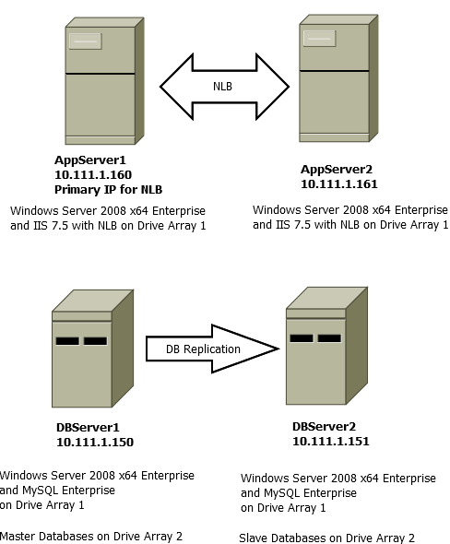

*Figure 1 - Basic Configuration*

# Hardware

## Application Servers

1. 2 CPU 4 core/CPU, 2.7 GHz+
2. 64 GB RAM
3. 2 x 500GB+ 10K RPM RAID 0 (system drive)
4. 3 x 500GB+ 10K RPM RAID 5 (data drive)
5. 1 x 500GB+ 10K RPM (global hot spare)
6. Dual gigabit Ethernet channels
7. Redundant power supplies
8. Rack installation hardware with fiber channels

## Database Servers

1. 2 CPU 4 core/CPU, 2.7 GHz+
2. 64 GB RAM
3. 2 x 500GB+ 10K RPM RAID 0 (system drive)
4. 3 x 500GB+ 10K RPM RAID 5 (data drive)
5. 1 x 500GB+ 10K RPM (global hot spare)
6. Dual gigabit Ethernet channels
7. Redundant power supplies
8. Rack installation hardware with fiber channels

# Basic Software Settings

Users of RAPTOR will only hit the Application Servers and thus only port 80 needs to be exposed outside the cluster. Inside the cluster, the ports identified in Table 1 and Table 2 need to be accessible.

# Configuration Starting Point

*Table 1 - Operating System, Http server*

|  |  |  |  |  |  |
| --- | --- | --- | --- | --- | --- |
| App Server1 | App Server2 | DB Server1 | DB Server2 | Software | Ports |
| Yes | **Yes** | **Yes** | **Yes** | Windows Server 2008 x64 | - |
| Yes | **Yes** | No | No | Network Load Balancing (WS Feature) | - |
| Yes | **Yes** | No | No | IIS 7.5 | 80 |
| Yes | **Yes** | **Yes** | **Yes** | .NET 4.5 | - |

# RAPTOR Stack

*Table 2 - RAPTOR Stack*

|  |  |  |  |  |  |
| --- | --- | --- | --- | --- | --- |
| App Server1 | App Server2 | DB Server1 | DB Server2 | Software | Ports |
| No | No | **Yes** | **Yes** | MySQL Enterprise 5.6 | 3306 |
| Yes | **Yes** | **Yes** | **Yes** | Drupal 7.28 | 80 |
| Yes | **Yes** | No | No | MDWS | 8080 |
| Yes | **Yes** | No | No | Vista RPC Broker (needed by MDWS) | 9200 |
| No | No | No | **Yes** | RAPTOR VIX | 8090 |
| No | No | No | **Yes** | Laurel Bridge (needed by VIX for DICOM) | ???? |
| Yes | **Yes** | No | No | Cache??? | ???? |

# User Acceptance Testing Configuration (UAT)

For user testing period (through the end of 2014) the boxes will be configured with RDP port access in addition to the configuration settings described elsewhere in this document.

During UAT, Vista system will be installed on same boxes as the MDWS installation. For production, the Vista system will be external to these boxes.